Bubble sort Algorithm
In this article, we will discuss the Bubble sort Algorithm. The working procedure of bubble sort is simplest. This article will be very helpful and interesting to students as they might face bubble sort as a question in their examinations. So, it is important to discuss the topic.
Bubble sort works on the repeatedly swapping of adjacent elements until they are not in the intended order. It is called bubble sort because the movement of array elements is just like the movement of air bubbles in the water. Bubbles in water rise up to the surface; similarly, the array elements in bubble sort move to the end in each iteration.
Although it is simple to use, it is primarily used as an educational tool because the performance of bubble sort is poor in the real world. It is not suitable for large data sets. The average and worst-case complexity of Bubble sort is O(n²), where n is a number of items.
Bubble short is majorly used where -
complexity does not matter
simple and shortcode is preferred

Algorithm
In the algorithm given below, suppose arr is an array of n elements. The assumed swap function in the algorithm will swap the values of given array elements.

begin BubbleSort(arr)
for all array elements
if arr[i] > arr[i+1]
swap(arr[i], arr[i+1])
end if
end for
return arr
end BubbleSort

Working of Bubble sort Algorithm
Now, let's see the working of Bubble sort Algorithm.
To understand the working of bubble sort algorithm, let's take an unsorted array. We are taking a short and accurate array, as we know the complexity of bubble sort is O(n²).
Let the elements of array are -
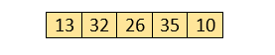

First Pass
Sorting will start from the initial two elements. Let compare them to check which is greater.
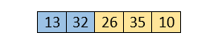
Here, 32 is greater than 13 (32 > 13), so it is already sorted. Now, compare 32 with 26.
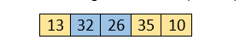
Here, 26 is smaller than 36. So, swapping is required. After swapping new array will look like -
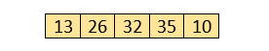
Now, compare 32 and 35.
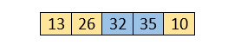
Here, 35 is greater than 32. So, there is no swapping required as they are already sorted.
Now, the comparison will be in between 35 and 10.
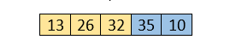
Here, 10 is smaller than 35 that are not sorted. So, swapping is required. Now, we reach at the end of the array. After first pass, the array will be -
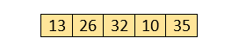
Now, move to the second iteration.

Second Pass
The same process will be followed for second iteration.
AD
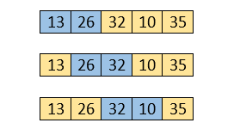
Here, 10 is smaller than 32. So, swapping is required. After swapping, the array will be -
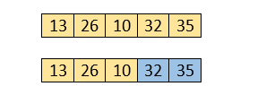
Now, move to the third iteration.

Third Pass
The same process will be followed for third iteration.
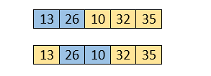
Here, 10 is smaller than 26. So, swapping is required. After swapping, the array will be -
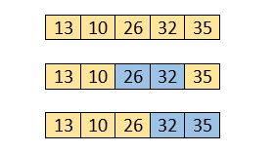
Now, move to the fourth iteration.
AD

Fourth pass
Similarly, after the fourth iteration, the array will be -
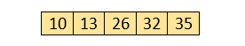
Hence, there is no swapping required, so the array is completely sorted.

Bubble sort complexity
Now, let's see the time complexity of bubble sort in the best case, average case, and worst case. We will also see the space complexity of bubble sort.

1. Time Complexity
Case | Time Complexity
Best Case | O(n)
Average Case | O(n²)
Worst Case | O(n²)
Best Case Complexity - It occurs when there is no sorting required, i.e. the array is already sorted. The best-case time complexity of bubble sort is O(n).
Average Case Complexity - It occurs when the array elements are in jumbled order that is not properly ascending and not properly descending. The average case time complexity of bubble sort is O(n²).
Worst Case Complexity - It occurs when the array elements are required to be sorted in reverse order. That means suppose you have to sort the array elements in ascending order, but its elements are in descending order. The worst-case time complexity of bubble sort is O(n²).
AD

2. Space Complexity
Space Complexity | O(1)
Stable | YES
The space complexity of bubble sort is O(1). It is because, in bubble sort, an extra variable is required for swapping.
The space complexity of optimized bubble sort is O(2). It is because two extra variables are required in optimized bubble sort.
Now, let's discuss the optimized bubble sort algorithm.
AD

Optimized Bubble sort Algorithm
In the bubble sort algorithm, comparisons are made even when the array is already sorted. Because of that, the execution time increases.
To solve it, we can use an extra variable swapped. It is set to true if swapping requires; otherwise, it is set to false.
It will be helpful, as suppose after an iteration, if there is no swapping required, the value of variable swapped will be false. It means that the elements are already sorted, and no further iterations are required.
This method will reduce the execution time and also optimizes the bubble sort.

Algorithm for optimized bubble sort

bubbleSort(array)
n = length(array)
repeat
swapped = false
for i = 1 to n - 1
if array[i - 1] > array[i], then
swap(array[i - 1], array[i])
swapped = true
end if
end for
n = n - 1
until not swapped
end bubbleSort

Implementation of Bubble sort
Program: Write a program to implement bubble sort in Java.

public class Bubble {
static void print (int a[]) //function to print array elements
{
int n = a.length;
int i;
for (i = 0; i < n; i++)
{
System.out.print(a[i] + " ");
}
}
static void bubbleSort (int a[]) // function to implement bubble sort
{
int n = a.length;
int i, j, temp;
for (i = 0; i < n; i++)
{
for (j = i + 1; j < n; j++)
{
if (a[j] < a[i])
{
temp = a[i];
a[i] = a[j];
a[j] = temp;
}
}
}
}
public static void main(String[] args) {
int a[] = {35, 10, 31, 11, 26};
Bubble b1 = new Bubble();
System.out.println("Before sorting array elements are - ");
b1.print(a);
b1.bubbleSort(a);
System.out.println();
System.out.println("After sorting array elements are - ");
b1.print(a);

}
}

Insertion Sort Algorithm
In this article, we will discuss the Insertion sort Algorithm. The working procedure of insertion sort is also simple. This article will be very helpful and interesting to students as they might face insertion sort as a question in their examinations. So, it is important to discuss the topic.
Insertion sort works similar to the sorting of playing cards in hands. It is assumed that the first card is already sorted in the card game, and then we select an unsorted card. If the selected unsorted card is greater than the first card, it will be placed at the right side; otherwise, it will be placed at the left side. Similarly, all unsorted cards are taken and put in their exact place.
The same approach is applied in insertion sort. The idea behind the insertion sort is that first take one element, iterate it through the sorted array. Although it is simple to use, it is not appropriate for large data sets as the time complexity of insertion sort in the average case and worst case is O(n²), where n is the number of items. Insertion sort is less efficient than the other sorting algorithms like heap sort, quick sort, merge sort, etc.
Insertion sort has various advantages such as -
Simple implementation
Efficient for small data sets
Adaptive, i.e., it is appropriate for data sets that are already substantially sorted.
Now, let's see the algorithm of insertion sort.

Algorithm
The simple steps of achieving the insertion sort are listed as follows -
Step 1 - If the element is the first element, assume that it is already sorted. Return 1.
Step2 - Pick the next element, and store it separately in a key.
Step3 - Now, compare the key with all elements in the sorted array.
Step 4 - If the element in the sorted array is smaller than the current element, then move to the next element. Else, shift greater elements in the array towards the right.
Step 5 - Insert the value.
Step 6 - Repeat until the array is sorted.

Working of Insertion sort Algorithm
Now, let's see the working of the insertion sort Algorithm.
To understand the working of the insertion sort algorithm, let's take an unsorted array. It will be easier to understand the insertion sort via an example.
Let the elements of array are -
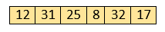
Initially, the first two elements are compared in insertion sort.
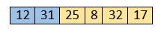
Here, 31 is greater than 12. That means both elements are already in ascending order. So, for now, 12 is stored in a sorted sub-array.
AD
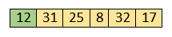
Now, move to the next two elements and compare them.
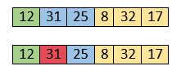
Here, 25 is smaller than 31. So, 31 is not at correct position. Now, swap 31 with 25. Along with swapping, insertion sort will also check it with all elements in the sorted array.
For now, the sorted array has only one element, i.e. 12. So, 25 is greater than 12. Hence, the sorted array remains sorted after swapping.
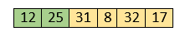
Now, two elements in the sorted array are 12 and 25. Move forward to the next elements that are 31 and 8.
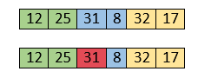
Both 31 and 8 are not sorted. So, swap them.
AD
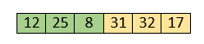
After swapping, elements 25 and 8 are unsorted.
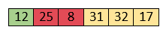
So, swap them.
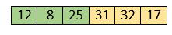
Now, elements 12 and 8 are unsorted.
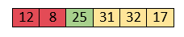
So, swap them too.
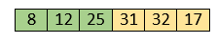
Now, the sorted array has three items that are 8, 12 and 25. Move to the next items that are 31 and 32.
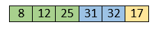
Hence, they are already sorted. Now, the sorted array includes 8, 12, 25 and 31.
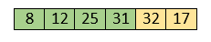
Move to the next elements that are 32 and 17.
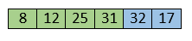
17 is smaller than 32. So, swap them.
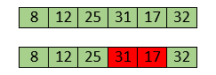
Swapping makes 31 and 17 unsorted. So, swap them too.
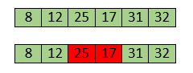
Now, swapping makes 25 and 17 unsorted. So, perform swapping again.
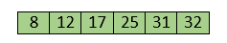
Now, the array is completely sorted.

Insertion sort complexity
Now, let's see the time complexity of insertion sort in best case, average case, and in worst case. We will also see the space complexity of insertion sort.

1. Time Complexity
Case | Time Complexity
Best Case | O(n)
Average Case | O(n²)
Worst Case | O(n²)
Best Case Complexity - It occurs when there is no sorting required, i.e. the array is already sorted. The best-case time complexity of insertion sort is O(n).
Average Case Complexity - It occurs when the array elements are in jumbled order that is not properly ascending and not properly descending. The average case time complexity of insertion sort is O(n²).
Worst Case Complexity - It occurs when the array elements are required to be sorted in reverse order. That means suppose you have to sort the array elements in ascending order, but its elements are in descending order. The worst-case time complexity of insertion sort is O(n²).
AD

2. Space Complexity
Space Complexity | O(1)
Stable | YES
The space complexity of insertion sort is O(1). It is because, in insertion sort, an extra variable is required for swapping.
AD

Program: Write a program to implement insertion sort in Java.

public class Insert
{
void insert(int a[]) /* function to sort an aay with insertion sort */
{
int i, j, temp;
int n = a.length;
for (i = 1; i < n; i++) {
temp = a[i];
j = i - 1;

while(j>=0 && temp <= a[j]) /* Move the elements greater than temp to one position ahead from their current position*/
{
a[j+1] = a[j];
j = j-1;
}
a[j+1] = temp;
}
}
void printArr(int a[]) /* function to print the array */
{
int i;
int n = a.length;
for (i = 0; i < n; i++)
System.out.print(a[i] + " ");
}

public static void main(String[] args) {
int a[] = { 92, 50, 5, 20, 11, 22 };
Insert i1 = new Insert();
System.out.println("\nBefore sorting array elements are - ");
i1.printArr(a);
i1.insert(a);
System.out.println("\n\nAfter sorting array elements are - ");
i1.printArr(a);
System.out.println();
}
}

Merge Sort Algorithm
In this article, we will discuss the merge sort Algorithm. Merge sort is the sorting technique that follows the divide and conquer approach. This article will be very helpful and interesting to students as they might face merge sort as a question in their examinations. In coding or technical interviews for software engineers, sorting algorithms are widely asked. So, it is important to discuss the topic.
Merge sort is similar to the quick sort algorithm as it uses the divide and conquer approach to sort the elements. It is one of the most popular and efficient sorting algorithm. It divides the given list into two equal halves, calls itself for the two halves and then merges the two sorted halves. We have to define the merge() function to perform the merging.
The sub-lists are divided again and again into halves until the list cannot be divided further. Then we combine the pair of one element lists into two-element lists, sorting them in the process. The sorted two-element pairs is merged into the four-element lists, and so on until we get the sorted list.
Now, let's see the algorithm of merge sort.

Algorithm
In the following algorithm, arr is the given array, beg is the starting element, and end is the last element of the array.

MERGE_SORT(arr, beg, end)

if beg < end
set mid = (beg + end)/2
MERGE_SORT(arr, beg, mid)
MERGE_SORT(arr, mid + 1, end)
MERGE (arr, beg, mid, end)
end of if

END MERGE_SORT
The important part of the merge sort is the MERGE function. This function performs the merging of two sorted sub-arrays that are A[beg…mid] and A[mid+1…end], to build one sorted array A[beg…end]. So, the inputs of the MERGE function are A[], beg, mid, and end.
The implementation of the MERGE function is given as follows -

/* Function to merge the subarrays of a[] */
void merge(int a[], int beg, int mid, int end)
{
int i, j, k;
int n1 = mid - beg + 1;
int n2 = end - mid;

int LeftArray[n1], RightArray[n2]; //temporary arrays

/* copy data to temp arrays */
for (int i = 0; i < n1; i++)
LeftArray[i] = a[beg + i];
for (int j = 0; j < n2; j++)
RightArray[j] = a[mid + 1 + j];

i = 0, /* initial index of first sub-array */
j = 0; /* initial index of second sub-array */
k = beg; /* initial index of merged sub-array */

while (i < n1 && j < n2)
{
if(LeftArray[i] <= RightArray[j])
{
a[k] = LeftArray[i];
i++;
}
else
{
a[k] = RightArray[j];
j++;
}
k++;
}
while (i<n1)
{
a[k] = LeftArray[i];
i++;
k++;
}

while (j<n2)
{
a[k] = RightArray[j];
j++;
k++;
}
}

Working of Merge sort Algorithm
Now, let's see the working of merge sort Algorithm.
To understand the working of the merge sort algorithm, let's take an unsorted array. It will be easier to understand the merge sort via an example.
Let the elements of array are -
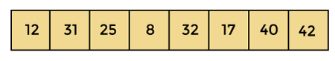
According to the merge sort, first divide the given array into two equal halves. Merge sort keeps dividing the list into equal parts until it cannot be further divided.
As there are eight elements in the given array, so it is divided into two arrays of size 4.
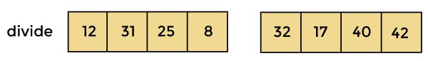
Now, again divide these two arrays into halves. As they are of size 4, so divide them into new arrays of size 2.
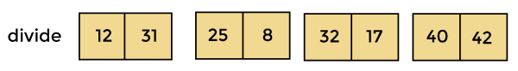
Now, again divide these arrays to get the atomic value that cannot be further divided.
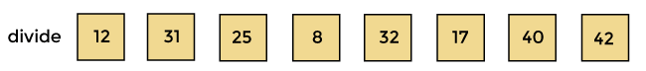
Now, combine them in the same manner they were broken.
In combining, first compare the element of each array and then combine them into another array in sorted order.
So, first compare 12 and 31, both are in sorted positions. Then compare 25 and 8, and in the list of two values, put 8 first followed by 25. Then compare 32 and 17, sort them and put 17 first followed by 32. After that, compare 40 and 42, and place them sequentially.
AD
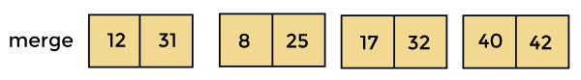
In the next iteration of combining, now compare the arrays with two data values and merge them into an array of found values in sorted order.
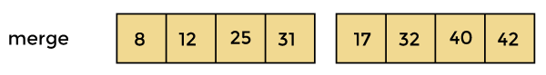
Now, there is a final merging of the arrays. After the final merging of above arrays, the array will look like -
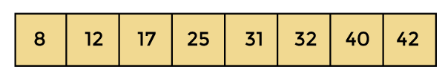
Now, the array is completely sorted.

Merge sort complexity
Now, let's see the time complexity of merge sort in best case, average case, and in worst case. We will also see the space complexity of the merge sort.

1. Time Complexity
Case | Time Complexity
Best Case | O(n*logn)
Average Case | O(n*logn)
Worst Case | O(n*logn)
Best Case Complexity - It occurs when there is no sorting required, i.e. the array is already sorted. The best-case time complexity of merge sort is O(n*logn).
Average Case Complexity - It occurs when the array elements are in jumbled order that is not properly ascending and not properly descending. The average case time complexity of merge sort is O(n*logn).
Worst Case Complexity - It occurs when the array elements are required to be sorted in reverse order. That means suppose you have to sort the array elements in ascending order, but its elements are in descending order. The worst-case time complexity of merge sort is O(n*logn).

2. Space Complexity
Space Complexity | O(n)
Stable | YES
The space complexity of merge sort is O(n). It is because, in merge sort, an extra variable is required for swapping.

class Merge {

/* Function to merge the subarrays of a[] */
void merge(int a[], int beg, int mid, int end)
{
int i, j, k;
int n1 = mid - beg + 1;
int n2 = end - mid;

/* temporary Arrays */
int LeftArray[] = new int[n1];
int RightArray[] = new int[n2];

/* copy data to temp arrays */
for (i = 0; i < n1; i++)
LeftArray[i] = a[beg + i];
for (j = 0; j < n2; j++)
RightArray[j] = a[mid + 1 + j];

i = 0; /* initial index of first sub-array */
j = 0; /* initial index of second sub-array */
k = beg; /* initial index of merged sub-array */

while (i < n1 && j < n2)
{
if(LeftArray[i] <= RightArray[j])
{
a[k] = LeftArray[i];
i++;
}
else
{
a[k] = RightArray[j];
j++;
}
k++;
}
while (i<n1)
{
a[k] = LeftArray[i];
i++;
k++;
}

while (j<n2)
{
a[k] = RightArray[j];
j++;
k++;
}
}

void mergeSort(int a[], int beg, int end)
{
if (beg < end)
{
int mid = (beg + end) / 2;
mergeSort(a, beg, mid);
mergeSort(a, mid + 1, end);
merge(a, beg, mid, end);
}
}

/* Function to print the array */
void printArray(int a[], int n)
{
int i;
for (i = 0; i < n; i++)
System.out.print(a[i] + " ");
}

public static void main(String args[])
{
int a[] = { 11, 30, 24, 7, 31, 16, 39, 41 };
int n = a.length;
Merge m1 = new Merge();
System.out.println("\nBefore sorting array elements are - ");
m1.printArray(a, n);
m1.mergeSort(a, 0, n - 1);
System.out.println("\nAfter sorting array elements are - ");
m1.printArray(a, n);
System.out.println("");
}

}
Output:
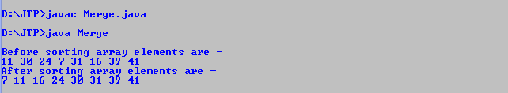
Program: Write a program to implement merge sort in C#.

using System;
class Merge {

/* Function to merge the subarrays of a[] */
static void merge(int[] a, int beg, int mid, int end)
{
int i, j, k;
int n1 = mid - beg + 1;
int n2 = end - mid;

//temporary arrays
int[] LeftArray = new int [n1];
int[] RightArray = new int [n2];

/* copy data to temp arrays */
for (i = 0; i < n1; i++)
LeftArray[i] = a[beg + i];
for (j = 0; j < n2; j++)
RightArray[j] = a[mid + 1 + j];

i = 0; /* initial index of first sub-array */
j = 0; /* initial index of second sub-array */
k = beg; /* initial index of merged sub-array */

while (i < n1 && j < n2)
{
if(LeftArray[i] <= RightArray[j])
{
a[k] = LeftArray[i];
i++;
}
else
{
a[k] = RightArray[j];
j++;
}
k++;
}
while (i<n1)
{
a[k] = LeftArray[i];
i++;
k++;
}

while (j<n2)
{
a[k] = RightArray[j];
j++;
k++;
}
}

static void mergeSort(int[] a, int beg, int end)
{
if (beg < end)
{
int mid = (beg + end) / 2;
mergeSort(a, beg, mid);
mergeSort(a, mid + 1, end);
merge(a, beg, mid, end);
}
}

/* Function to print the array */
static void printArray(int[] a, int n)
{
int i;
for (i = 0; i < n; i++)
Console.Write(a[i] + " ");
}

static void Main()
{
int[] a = { 10, 29, 23, 6, 30, 15, 38, 40 };
int n = a.Length;
Console.Write("Before sorting array elements are - ");
printArray(a, n);
mergeSort(a, 0, n - 1);
Console.Write("\nAfter sorting array elements are - ");
printArray(a, n);
}

}

Quick Sort Algorithm
In this article, we will discuss the Quicksort Algorithm. The working procedure of Quicksort is also simple. This article will be very helpful and interesting to students as they might face quicksort as a question in their examinations. So, it is important to discuss the topic.
Sorting is a way of arranging items in a systematic manner. Quicksort is the widely used sorting algorithm that makes n log n comparisons in average case for sorting an array of n elements. It is a faster and highly efficient sorting algorithm. This algorithm follows the divide and conquer approach. Divide and conquer is a technique of breaking down the algorithms into subproblems, then solving the subproblems, and combining the results back together to solve the original problem.
Divide: In Divide, first pick a pivot element. After that, partition or rearrange the array into two sub-arrays such that each element in the left sub-array is less than or equal to the pivot element and each element in the right sub-array is larger than the pivot element.
Conquer: Recursively, sort two subarrays with Quicksort.
Combine: Combine the already sorted array.
Quicksort picks an element as pivot, and then it partitions the given array around the picked pivot element. In quick sort, a large array is divided into two arrays in which one holds values that are smaller than the specified value (Pivot), and another array holds the values that are greater than the pivot.
After that, left and right sub-arrays are also partitioned using the same approach. It will continue until the single element remains in the sub-array.
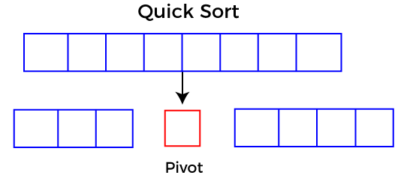

Choosing the pivot
Picking a good pivot is necessary for the fast implementation of quicksort. However, it is typical to determine a good pivot. Some of the ways of choosing a pivot are as follows -
Pivot can be random, i.e. select the random pivot from the given array.
Pivot can either be the rightmost element of the leftmost element of the given array.
Select median as the pivot element.

Algorithm
Algorithm:

QUICKSORT (array A, start, end)
{
1 if (start < end)
2 {
3 p = partition(A, start, end)
4 QUICKSORT (A, start, p - 1)
5 QUICKSORT (A, p + 1, end)
6 }
}
Partition Algorithm:
The partition algorithm rearranges the sub-arrays in a place.

PARTITION (array A, start, end)
{
1 pivot ? A[end]
2 i ? start-1
3 for j ? start to end -1 {
4 do if (A[j] < pivot) {
5 then i ? i + 1
6 swap A[i] with A[j]
7 }}
8 swap A[i+1] with A[end]
9 return i+1
}

Working of Quick Sort Algorithm
Now, let's see the working of the Quicksort Algorithm.
To understand the working of quick sort, let's take an unsorted array. It will make the concept more clear and understandable.
Let the elements of array are -
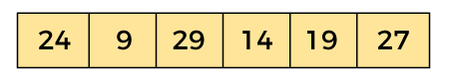
In the given array, we consider the leftmost element as pivot. So, in this case, a[left] = 24, a[right] = 27 and a[pivot] = 24.
Since, pivot is at left, so algorithm starts from right and move towards left.
Now, a[pivot] < a[right], so algorithm moves forward one position towards left, i.e. -
AD
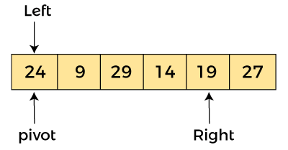
Now, a[left] = 24, a[right] = 19, and a[pivot] = 24.
Because, a[pivot] > a[right], so, algorithm will swap a[pivot] with a[right], and pivot moves to right, as -
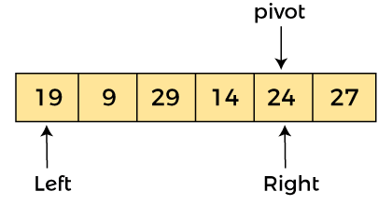
Now, a[left] = 19, a[right] = 24, and a[pivot] = 24. Since, pivot is at right, so algorithm starts from left and moves to right.
As a[pivot] > a[left], so algorithm moves one position to right as -
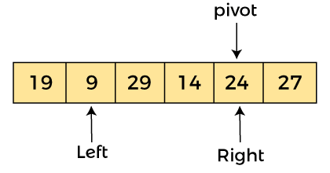
Now, a[left] = 9, a[right] = 24, and a[pivot] = 24. As a[pivot] > a[left], so algorithm moves one position to right as -
AD
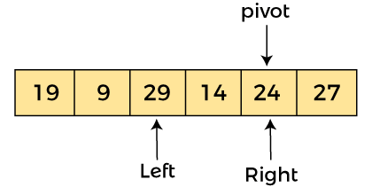
Now, a[left] = 29, a[right] = 24, and a[pivot] = 24. As a[pivot] < a[left], so, swap a[pivot] and a[left], now pivot is at left, i.e. -
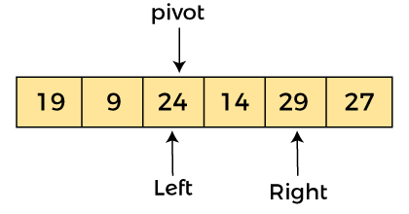
Since, pivot is at left, so algorithm starts from right, and move to left. Now, a[left] = 24, a[right] = 29, and a[pivot] = 24. As a[pivot] < a[right], so algorithm moves one position to left, as -
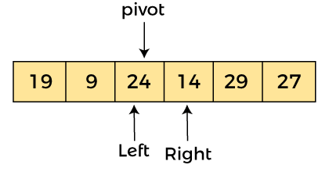
Now, a[pivot] = 24, a[left] = 24, and a[right] = 14. As a[pivot] > a[right], so, swap a[pivot] and a[right], now pivot is at right, i.e. -
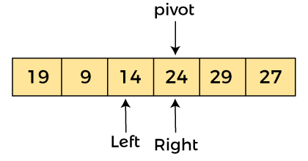
Now, a[pivot] = 24, a[left] = 14, and a[right] = 24. Pivot is at right, so the algorithm starts from left and move to right.
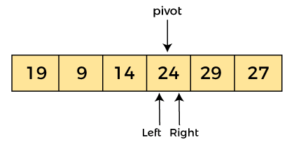
Now, a[pivot] = 24, a[left] = 24, and a[right] = 24. So, pivot, left and right are pointing the same element. It represents the termination of procedure.
Element 24, which is the pivot element is placed at its exact position.
Elements that are right side of element 24 are greater than it, and the elements that are left side of element 24 are smaller than it.
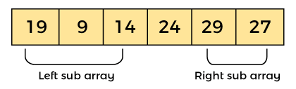
Now, in a similar manner, quick sort algorithm is separately applied to the left and right sub-arrays. After sorting gets done, the array will be -
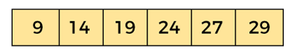
AD

Quicksort complexity
Now, let's see the time complexity of quicksort in best case, average case, and in worst case. We will also see the space complexity of quicksort.

1. Time Complexity
Case | Time Complexity
Best Case | O(n*logn)
Average Case | O(n*logn)
Worst Case | O(n²)
Best Case Complexity - In Quicksort, the best-case occurs when the pivot element is the middle element or near to the middle element. The best-case time complexity of quicksort is O(n*logn).
Average Case Complexity - It occurs when the array elements are in jumbled order that is not properly ascending and not properly descending. The average case time complexity of quicksort is O(n*logn).
Worst Case Complexity - In quick sort, worst case occurs when the pivot element is either greatest or smallest element. Suppose, if the pivot element is always the last element of the array, the worst case would occur when the given array is sorted already in ascending or descending order. The worst-case time complexity of quicksort is O(n²).
AD
Though the worst-case complexity of quicksort is more than other sorting algorithms such as Merge sort and Heap sort, still it is faster in practice. Worst case in quick sort rarely occurs because by changing the choice of pivot, it can be implemented in different ways. Worst case in quicksort can be avoided by choosing the right pivot element.

2. Space Complexity
Space Complexity | O(n*logn)
Stable | NO
The space complexity of quicksort is O(n*logn).

Program: Write a program to implement quicksort in Java.

public class Quick
{
/* function that consider last element as pivot,
place the pivot at its exact position, and place
smaller elements to left of pivot and greater
elements to right of pivot. */
int partition (int a[], int start, int end)
{
int pivot = a[end]; // pivot element
int i = (start - 1);

for (int j = start; j <= end - 1; j++)
{
// If current element is smaller than the pivot
if (a[j] < pivot)
{
i++; // increment index of smaller element
int t = a[i];
a[i] = a[j];
a[j] = t;
}
}
int t = a[i+1];
a[i+1] = a[end];
a[end] = t;
return (i + 1);
}

/* function to implement quick sort */
void quick(int a[], int start, int end) /* a[] = array to be sorted, start = Starting index, end = Ending index */
{
if (start < end)
{
int p = partition(a, start, end); //p is partitioning index
quick(a, start, p - 1);
quick(a, p + 1, end);
}
}

/* function to print an array */
void printArr(int a[], int n)
{
int i;
for (i = 0; i < n; i++)
System.out.print(a[i] + " ");
}
public static void main(String[] args) {
int a[] = { 13, 18, 27, 2, 19, 25 };
int n = a.length;
System.out.println("\nBefore sorting array elements are - ");
Quick q1 = new Quick();
q1.printArr(a, n);
q1.quick(a, 0, n - 1);
System.out.println("\nAfter sorting array elements are - ");
q1.printArr(a, n);
System.out.println();
}
}

Selection Sort Algorithm
In this article, we will discuss the Selection sort Algorithm. The working procedure of selection sort is also simple. This article will be very helpful and interesting to students as they might face selection sort as a question in their examinations. So, it is important to discuss the topic.
In selection sort, the smallest value among the unsorted elements of the array is selected in every pass and inserted to its appropriate position into the array. It is also the simplest algorithm. It is an in-place comparison sorting algorithm. In this algorithm, the array is divided into two parts, first is sorted part, and another one is the unsorted part. Initially, the sorted part of the array is empty, and unsorted part is the given array. Sorted part is placed at the left, while the unsorted part is placed at the right.
In selection sort, the first smallest element is selected from the unsorted array and placed at the first position. After that second smallest element is selected and placed in the second position. The process continues until the array is entirely sorted.
The average and worst-case complexity of selection sort is O(n²), where n is the number of items. Due to this, it is not suitable for large data sets.
Selection sort is generally used when -
A small array is to be sorted
Swapping cost doesn't matter
It is compulsory to check all elements
Now, let's see the algorithm of selection sort.

Algorithm

SELECTION SORT(arr, n)

Step 1: Repeat Steps 2 and 3 for i = 0 to n-1
Step 2: CALL SMALLEST(arr, i, n, pos)
Step 3: SWAP arr[i] with arr[pos]
[END OF LOOP]
Step 4: EXIT

SMALLEST (arr, i, n, pos)
Step 1: [INITIALIZE] SET SMALL = arr[i]
Step 2: [INITIALIZE] SET pos = i
Step 3: Repeat for j = i+1 to n
if (SMALL > arr[j])
SET SMALL = arr[j]
SET pos = j
[END OF if]
[END OF LOOP]
Step 4: RETURN pos

Working of Selection sort Algorithm
Now, let's see the working of the Selection sort Algorithm.
To understand the working of the Selection sort algorithm, let's take an unsorted array. It will be easier to understand the Selection sort via an example.
Let the elements of array are -
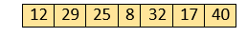
Now, for the first position in the sorted array, the entire array is to be scanned sequentially.
At present, 12 is stored at the first position, after searching the entire array, it is found that 8 is the smallest value.
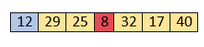
So, swap 12 with 8. After the first iteration, 8 will appear at the first position in the sorted array.
For the second position, where 29 is stored presently, we again sequentially scan the rest of the items of unsorted array. After scanning, we find that 12 is the second lowest element in the array that should be appeared at second position.
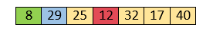
Now, swap 29 with 12. After the second iteration, 12 will appear at the second position in the sorted array. So, after two iterations, the two smallest values are placed at the beginning in a sorted way.
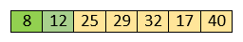
The same process is applied to the rest of the array elements. Now, we are showing a pictorial representation of the entire sorting process.
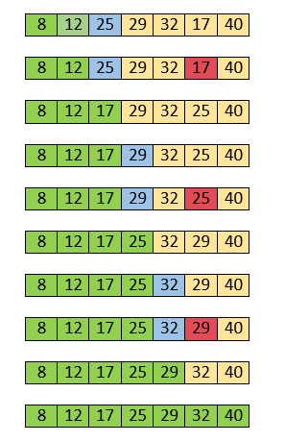
Now, the array is completely sorted.

Selection sort complexity
Now, let's see the time complexity of selection sort in best case, average case, and in worst case. We will also see the space complexity of the selection sort.
AD

1. Time Complexity
Case | Time Complexity
Best Case | O(n²)
Average Case | O(n²)
Worst Case | O(n²)
Best Case Complexity - It occurs when there is no sorting required, i.e. the array is already sorted. The best-case time complexity of selection sort is O(n²).
Average Case Complexity - It occurs when the array elements are in jumbled order that is not properly ascending and not properly descending. The average case time complexity of selection sort is O(n²).
Worst Case Complexity - It occurs when the array elements are required to be sorted in reverse order. That means suppose you have to sort the array elements in ascending order, but its elements are in descending order. The worst-case time complexity of selection sort is O(n²).
AD

2. Space Complexity
Space Complexity | O(1)
Stable | YES
The space complexity of selection sort is O(1). It is because, in selection sort, an extra variable is required for swapping.
Program: Write a program to implement selection sort in Java.

public class Selection
{
void selection(int a[]) /* function to sort an array with selection sort */
{
int i, j, small;
int n = a.length;
for (i = 0; i < n-1; i++)
{
small = i; //minimum element in unsorted array

for (j = i+1; j < n; j++)
if (a[j] < a[small])
small = j;
// Swap the minimum element with the first element
int temp = a[small];
a[small] = a[i];
a[i] = temp;
}

}
void printArr(int a[]) /* function to print the array */
{
int i;
int n = a.length;
for (i = 0; i < n; i++)
System.out.print(a[i] + " ");
}

public static void main(String[] args) {
int a[] = { 91, 49, 4, 19, 10, 21 };
Selection i1 = new Selection();
System.out.println("\nBefore sorting array elements are - ");
i1.printArr(a);
i1.selection(a);
System.out.println("\nAfter sorting array elements are - ");
i1.printArr(a);
System.out.println();
}
}

